Dažādu DBVS telpiskie paplašinājumi
1. Oracle Spatial.
2. SQL Server 2008 Spatial paplašinājums.
3. PostgreSQL PostGIS.
4. IBM DB2 Spatial Extender.
5. IBM Informix Spatial Blade.
6. MySQL Spatial u.c.



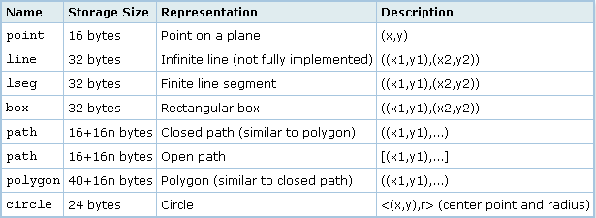

Operator | Description | Example
+ | Translation | box '((0,0),(1,1))' + point '(2.0,0)'
- | Translation | box '((0,0),(1,1))' - point '(2.0,0)'
* | Scaling/rotation | box '((0,0),(1,1))' * point '(2.0,0)'
/ | Scaling/rotation | box '((0,0),(2,2))' / point '(2.0,0)'
# | Point or box of intersection | '((1,-1),(-1,1))' # '((1,1),(-1,-1))'
# | Number of points in path or polygon | # '((1,0),(0,1),(-1,0))'
@-@ | Length or circumference | @-@ path '((0,0),(1,0))'
@@ | Center | @@ circle '((0,0),10)'
## | Closest point to first operand on second operand | point '(0,0)' ## lseg '((2,0),(0,2))'
<-> | Distance between | circle '((0,0),1)' <-> circle '((5,0),1)'
&& | Overlaps? (One point in common makes this true.) | box '((0,0),(1,1))' && box '((0,0),(2,2))'
<< | Is strictly left of? | circle '((0,0),1)' << circle '((5,0),1)'
>> | Is strictly right of? | circle '((5,0),1)' >> circle '((0,0),1)'
&< | Does not extend to the right of? | box '((0,0),(1,1))' &< box '((0,0),(2,2))'
&> | Does not extend to the left of? | box '((0,0),(3,3))' &> box '((0,0),(2,2))'
<<| | Is strictly below? | box '((0,0),(3,3))' <<| box '((3,4),(5,5))'
|>> | Is strictly above? | box '((3,4),(5,5))' |>> box '((0,0),(3,3))'
&<| | Does not extend above? | box '((0,0),(1,1))' &<| box '((0,0),(2,2))'
|&> | Does not extend below? | box '((0,0),(3,3))' |&> box '((0,0),(2,2))'
<^ | Is below (allows touching)? | circle '((0,0),1)' <^ circle '((0,5),1)'
>^ | Is above (allows touching)? | circle '((0,5),1)' >^ circle '((0,0),1)'
?# | Intersects? | lseg '((-1,0),(1,0))' ?# box '((-2,-2),(2,2))'
?- | Is horizontal? | ?- lseg '((-1,0),(1,0))'
?- | Are horizontally aligned? | point '(1,0)' ?- point '(0,0)'
?| | Is vertical? | ?| lseg '((-1,0),(1,0))'
?| | Are vertically aligned? | point '(0,1)' ?| point '(0,0)'
?-| | Is perpendicular? | lseg '((0,0),(0,1))' ?-| lseg '((0,0),(1,0))'
?|| | Are parallel? | lseg '((-1,0),(1,0))' ?|| lseg '((-1,2),(1,2))'
@> | Contains? | circle '((0,0),2)' @> point '(1,1)'
<@ | Contained in or on? | point '(1,1)' <@ circle '((0,0),2)'
~= | Same as? | polygon '((0,0),(1,1))' ~= polygon '((1,1),(0,0))'

Function | Return Type | Description | Example
area(object) | double precision | area | area(box '((0,0),(1,1))')
center(object) | point | center | center(box '((0,0),(1,2))')
diameter(circle) | double precision | diameter of circle | diameter(circle '((0,0),2.0)')
height(box) | double precision | vertical size of box | height(box '((0,0),(1,1))')
isclosed(path) | boolean | a closed path? | isclosed(path '((0,0),(1,1),(2,0))')
isopen(path) | boolean | an open path? | isopen(path '[(0,0),(1,1),(2,0)]')
length(object) | double precision | length | length(path '((-1,0),(1,0))')
npoints(path) | int | number of points | npoints(path '[(0,0),(1,1),(2,0)]')
npoints(polygon) | int | number of points | npoints(polygon '((1,1),(0,0))')
pclose(path) | path | convert path to closed | pclose(path '[(0,0),(1,1),(2,0)]')
popen(path) | path | convert path to open | popen(path '((0,0),(1,1),(2,0))')
radius(circle) | double precision | radius of circle | radius(circle '((0,0),2.0)')
width(box) | double precision | horizontal size of box | width(box '((0,0),(1,1))')

